**Electrode Prep**

1. Make sure the clamp for the electrode to be replaced is far back into the drive
2. Place triade drive in question on an appropriate mount (horizontal is recommended).
3. Clear the appropriate guide-tube for the clamp in question with a used/broken electrode. These should be clearly marked with tape or some other marker
   1. If guide tube is not clear, consider taking it out and placing in cetylcide over night. Only consider removing guide tubes if no current electrodes are to be kept
   2. Alternatively, try pouring alcohol down the guide tubes before trying to clear them again
4. Carefully remove appropriate electrode. Make note of which end is the recording end and avoid damaging it.
5. 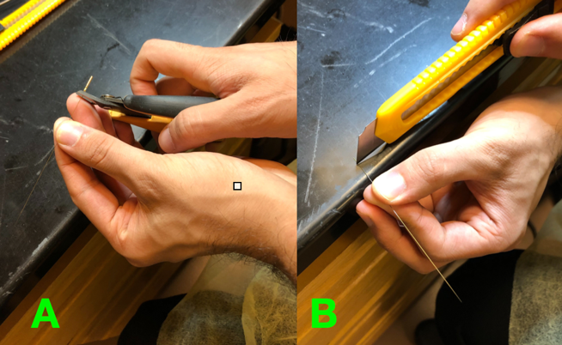If the electrode already has a gold pin on one end, it must first be removed. Note you can determine length of electrodes here as desired
6. At the same end where the gold pin was removed, remove a few mm of insulation on all sides by using a box cutter and rotating the electrode as you strip the insulation.
   1. NOTE: BE CAREFUL NOT TO DAMAGE THE ELECTRODE TIP HERE
7. Slowly back load (the back of the electrode is the stripped end) into the correct guide tube. Move the electrode back while applying modest amounts of silicone oil to the electrode body (never the tip). Make sure the tip is not exposed and is inside the guide tubes
8. Clamp the electrode, leaving at least 1cm at the end and tighten
   1. 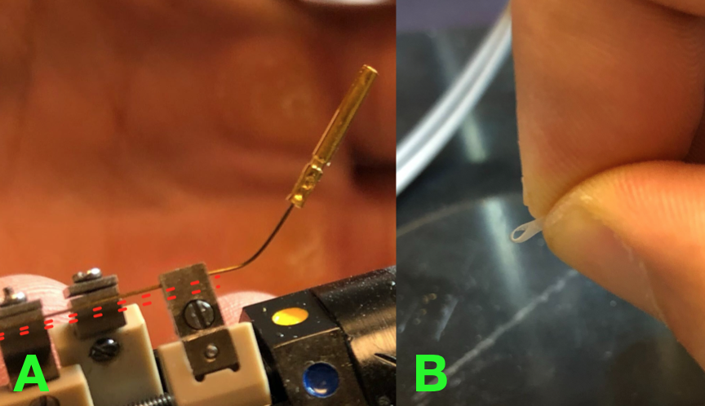A long electrode tail will be easier to place a pin on, but will be more likely to touch other electrode tails if there are many electrodes/drives being used causing conduction and identical signals between conducting electrodes
9. If you are using a thinner electrode (e.g. 125 micron thickness), you will need to increase the thickness in order for the clamps to grip the electrodes. You can create a loop of tape (as seen in figure B) and wrap around the clamped portion of the electrode.
10. Slightly bend the electrode end/tail… note it should be stable and firmly held by the clamp. Load a gold pin into the crimper by having the shorter end pointing up (Fig A). Grip the shorter part of the gold pin with minimal strength required to keep it in place (Fig B; DO NOT CRIMP AT THIS POINT!). Remove the drive for mobility and orient the electrode end/tail such that it is inside of the gold pin and crimp the pin onto the electrode to achieve Fig C.

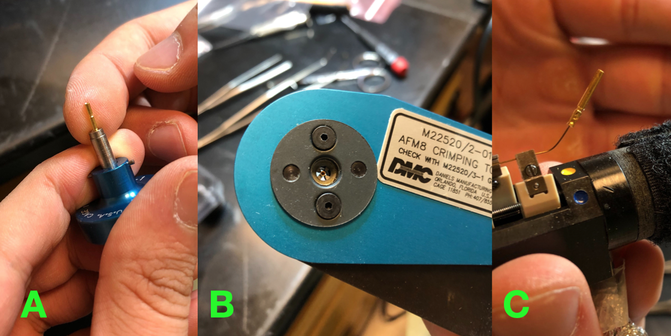

1. Plug in and turn on the soldering iron and pour some tap water onto the sponge. Unwind some of the tin wire and orient behind/above the gold pin’s contact point to the electrode. The goal here is to solder the gold pin for extra security onto the electrode. You can confirm this is done well by checking the gold pin’s crimped end to see if some tin is contacting both the gold and the wire simultaneously.
2. Clean up your work station
3. Update the number of electrodes used and available on TEBA (/Volumes/Womelsdorf Lab/Procedures and SOPs/Recordings/Vanderbilt_Recording_Drives_Info.xlsx)